**Digital Story Writing Workshop for Female Students**

The University of Poonch, Rawalakot, organized a digital story writing workshop exclusively for female students. The event aimed to equip participants with the skills to combine traditional storytelling with modern digital tools. Students were guided on crafting engaging narratives and integrating multimedia elements such as images, audio, and video to create impactful digital stories. The workshop also emphasized the importance of storytelling in personal expression, education, and addressing social issues.

This initiative provided a platform for female students to explore their creativity and boost their confidence in digital communication. By bridging the gap between traditional writing and digital media, the workshop empowered participants to share their unique perspectives effectively. Such programs are a vital step towards fostering innovation and encouraging young women to contribute meaningfully to the digital world.

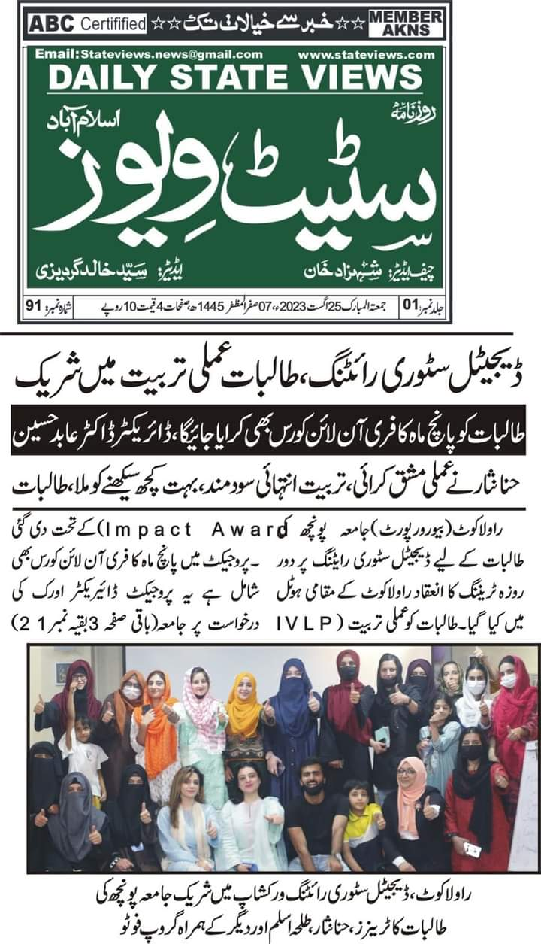

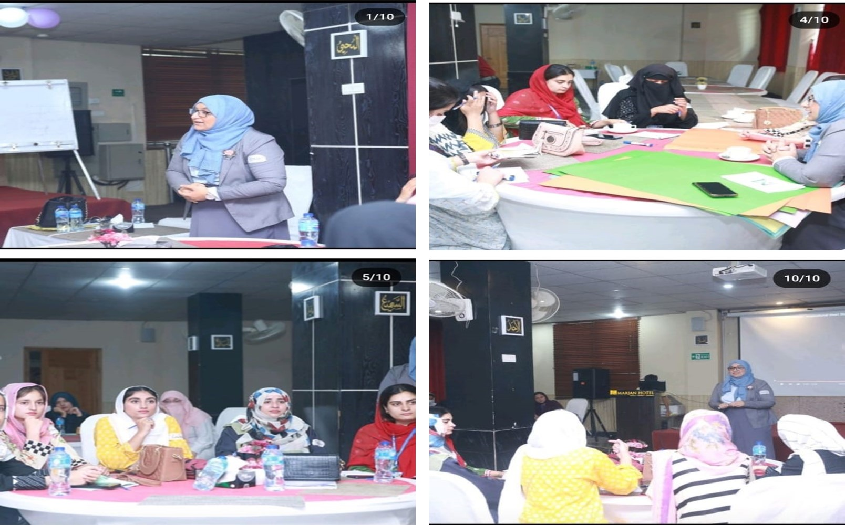

Few Glimpses from the workshop